**Issue:**

The [LTDS Grid Modelling Annex 2 - Data Exchange Specifications](https://www.ofgem.gov.uk/sites/default/files/2024-04/LTDS%20Grid%20Modelling%20Annex%202%20-%20Data%20Exchange%20Specifications.pdf), page 32, states that the BoundaryPoint class does not support the parameters from the European package (fromEndIsoCode, fromEndName, etc.)

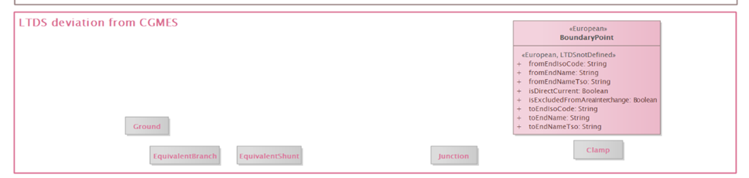

However, these parameters can still be found in the RDFS-Merged file for the EQ profile, and are defined as “required” ([Grid Modelling Appendix 3 - LTDS Profiles in RDFS (zip)](https://www.ofgem.gov.uk/sites/default/files/2024-04/Grid_Modelling_Appendix_3_LTDS_Profiles_in_RDFS.zip)).

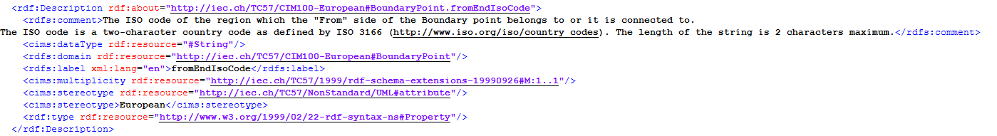

This is causing problems in CIM validation of LTDS data.

**Analysis:**

This appears to occur because there is both an <<LTDSnotDefined>> stereotype and another stereotype (other than <<deprecated>>) on an attribute in the deviation profile.

A check of all the deviation profiles for attributes with multiple stereotypes nets the following:

|  |  |  |  |  |  |  |  |
| --- | --- | --- | --- | --- | --- | --- | --- |
| **EQ** |  |  | in UML | | in LTDS_Deviation | | in LTDS_  Merged |
|  | BoundaryPoint | |  |  |  |  |  |
|  |  | fromEndISOCode | European | LTDSnotDefined | European | LTDSnotDefined | Y |
|  |  | fromEndName | European | LTDSnotDefined | European | LTDSnotDefined | Y |
|  |  | fromEndNameTso | European | LTDSnotDefined | European | LTDSnotDefined | Y |
|  |  | isDirectCurrent | European | LTDSnotDefined | European | LTDSnotDefined | Y |
|  |  | isExcludedFromAreaInterchange | European | LTDSnotDefined | European | LTDSnotDefined | Y |
|  |  | toEndISOCode | European | LTDSnotDefined | European | LTDSnotDefined | Y |
|  |  | toEndName | European | LTDSnotDefined | European | LTDSnotDefined | Y |
|  |  | toEndNameTso | European | LTDSnotDefined | European | LTDSnotDefined | Y |
|  |  |  |  |  |  |  |  |
|  | IdentifiedObject | |  |  |  |  |  |
|  |  | energyIdentCodeEic | European | LTDSnotDefined | European | LTDSnotDefined | Y |
|  |  | shortName | European | LTDSnotDefined | European | LTDSnotDefined | Y |
|  |  |  |  |  |  |  |  |
|  | PhaseTapChangerLinear | |  |  |  |  |  |
|  |  | xMin | deprecated | LTDSnotDefined | deprecated | LTDSnotDefined | N |
|  | PhaseTapChangerNonLinear | |  |  |  |  |  |
|  |  | xMin | deprecated | LTDSnotDefined | deprecated | LTDSnotDefined | N |
|  |  |  |  |  |  |  |  |
|  | StaticVarCompensator | |  |  |  |  |  |
|  |  | sVCControlMode | LTDSnotDefined | deprecated | LTDSnotDefined | deprecated | N |
|  |  | voltageSetPoint | LTDSnotDefined | deprecated | LTDSnotDefined | deprecated | N |
|  |  |  |  |  |  |  |  |
|  |  | Attribute erroneously appears in EQ merged profile | |  |  |  |  |
|  |  | Attribute correctly removed from EQ merged profile | |  |  |  |  |

Note that all attributes with an <<LTDSnotDefined>> that also have another stereotype are in EQ, so the problem is confined to EQ.

UML

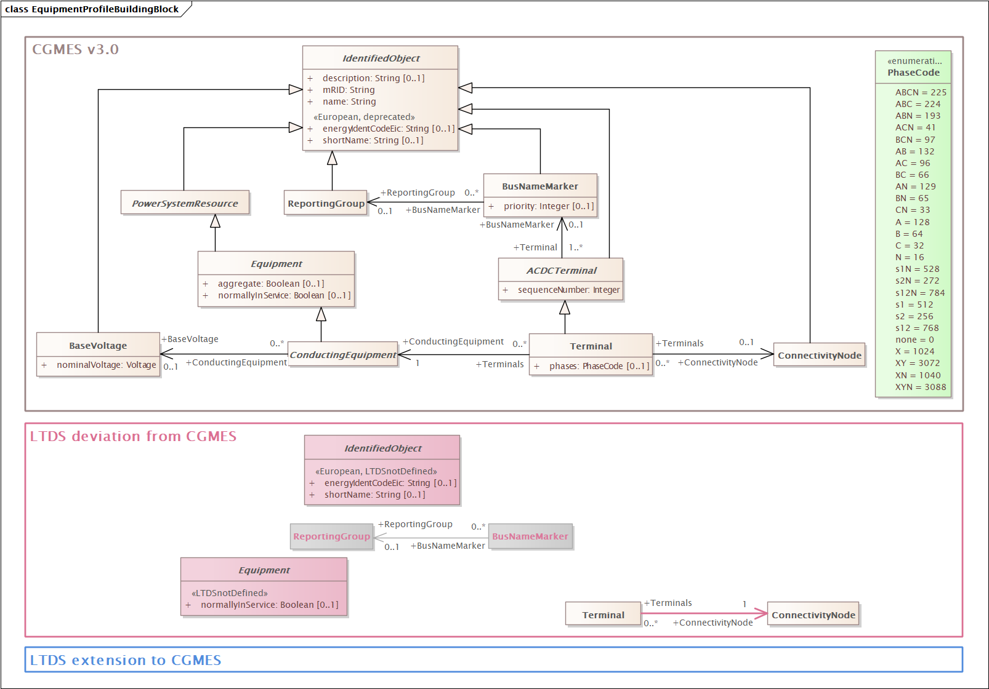

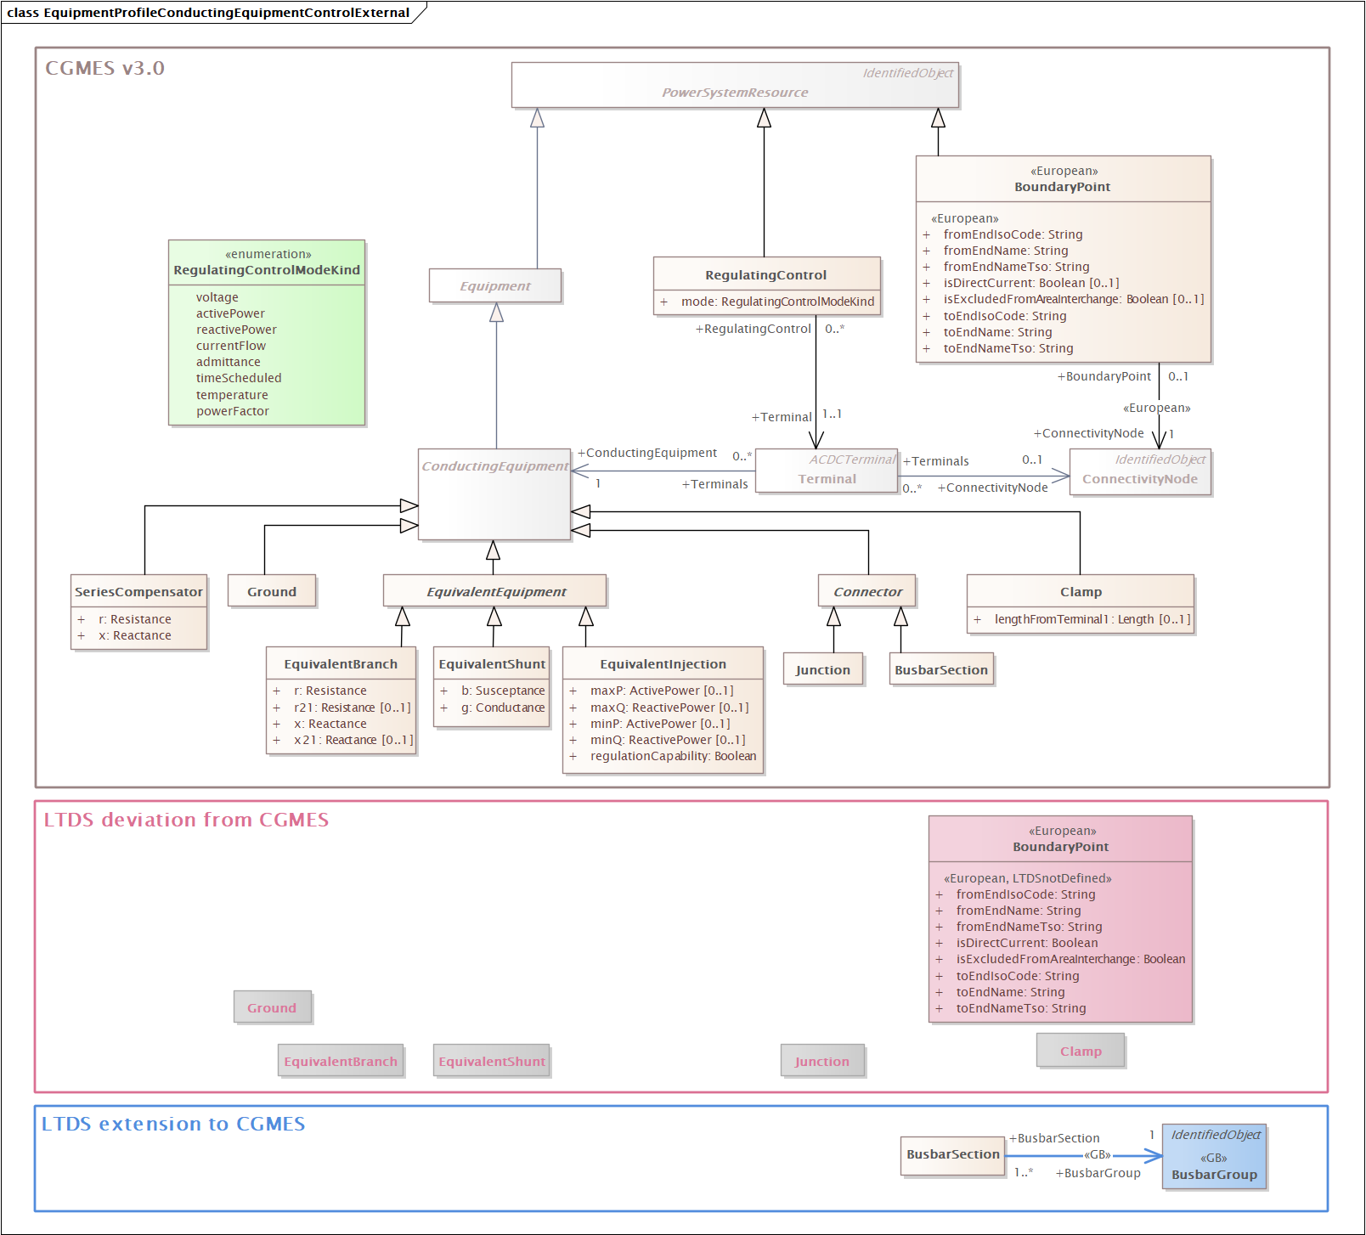

It turns out that where both the <<European>> and <<LTDSnotDefined>> stereotypes exist on an attribute in the UML deviation profile, CIMSyntaxGen is putting an erroneous namespace on the attribute resource in the RDFS deviation profile. This causes the merging software to not identify the attribute as one to delete from the CGMES RDFS profile in creating the RDF merged profile.

The examples below illustrate the error in both the BoundaryPoint and IdentifiedObject classes. Note that

* the attribute namespace is not correct for either attribute (it should be <http://iec.ch/TC57/CIM100-European>, not <http://iec.ch/TC57/CIM100>).
* the BoundaryPoint class namespace illustrates how the <<European>> stereotype should have manifested in the RDFS for the 2 attributes but didn’t

In EQ deviation profile:

BoundaryPoint example

<rdf:Description rdf:about="http://iec.ch/TC57/CIM100-European#BoundaryPoint">

<rdfs:label xml:lang="en">BoundaryPoint</rdfs:label>

<rdfs:comment rdf:datatype="http://www.w3.org/2001/XMLSchema#string">Designates a connection point at which one or more model authority sets shall connect to. The location of the connection point as well as other properties are agreed between organisations responsible for the interconnection, hence all attributes of the class represent this agreement. It is primarily used in a boundary model authority set which can contain one or many BoundaryPoint-s among other Equipment-s and their connections.</rdfs:comment>

<cims:stereotype>European</cims:stereotype>

<cims:belongsToCategory rdf:resource="http://ofgem.gov.uk/ns/CIM/LTDS/DeviationEQ#Package_LTDSdeviationCGMESEquipmentProfile"/>

<cims:stereotype rdf:resource="http://iec.ch/TC57/NonStandard/UML#concrete"/>

<rdf:type rdf:resource="http://www.w3.org/2000/01/rdf-schema#Class"/>

</rdf:Description>

<rdf:Description rdf:about="http://iec.ch/TC57/CIM100#BoundaryPoint.fromEndIsoCode">

<cims:stereotype rdf:resource="http://iec.ch/TC57/NonStandard/UML#attribute"/>

<rdfs:label xml:lang="en">fromEndIsoCode</rdfs:label>

<rdfs:domain rdf:resource="http://iec.ch/TC57/CIM100-European#BoundaryPoint"/>

<cims:dataType rdf:resource="#String"/>

<cims:multiplicity rdf:resource="http://iec.ch/TC57/1999/rdf-schema-extensions-19990926#M:1..1"/>

<cims:stereotype>European</cims:stereotype>

<cims:stereotype>LTDSnotDefined</cims:stereotype>

<rdfs:comment rdf:datatype="http://www.w3.org/2001/XMLSchema#string">The ISO code of the region which the &quot;From&quot; side of the Boundary point belongs to or it is connected to.

The ISO code is a two-character country code as defined by ISO 3166 (http://www.iso.org/iso/country_codes). The length of the string is 2 characters maximum.</rdfs:comment>

<rdf:type rdf:resource="http://www.w3.org/1999/02/22-rdf-syntax-ns#Property"/>

</rdf:Description>

Identified Object example

<rdf:Description rdf:about="#IdentifiedObject">

<rdfs:label xml:lang="en">IdentifiedObject</rdfs:label>

<rdfs:comment rdf:datatype="http://www.w3.org/2001/XMLSchema#string">This is a root class to provide common identification for all classes needing identification and naming attributes.</rdfs:comment>

<cims:belongsToCategory rdf:resource="http://ofgem.gov.uk/ns/CIM/LTDS/DeviationEQ#Package_LTDSdeviationCGMESEquipmentProfile"/>

<rdf:type rdf:resource="http://www.w3.org/2000/01/rdf-schema#Class"/>

</rdf:Description>

<rdf:Description rdf:about="http://iec.ch/TC57/CIM100#IdentifiedObject.energyIdentCodeEic">

<cims:stereotype rdf:resource="http://iec.ch/TC57/NonStandard/UML#attribute"/>

<rdfs:label xml:lang="en">energyIdentCodeEic</rdfs:label>

<rdfs:domain rdf:resource="#IdentifiedObject"/>

<cims:dataType rdf:resource="#String"/>

<cims:multiplicity rdf:resource="http://iec.ch/TC57/1999/rdf-schema-extensions-19990926#M:0..1"/>

<cims:stereotype>European</cims:stereotype>

<cims:stereotype>LTDSnotDefined</cims:stereotype>

<rdfs:comment rdf:datatype="http://www.w3.org/2001/XMLSchema#string">The attribute is used for an exchange of the EIC code (Energy identification Code). The length of the string is 16 characters as defined by the EIC code. For details on EIC scheme please refer to ENTSO-E web site.</rdfs:comment>

<rdf:type rdf:resource="http://www.w3.org/1999/02/22-rdf-syntax-ns#Property"/>

</rdf:Description>

It is not clear whether <<LTDSnotDefined>> being the second stereotype is a factor or not in CIMSyntaxGen failing to recognise the <<European>> attribute.

**Corrective Action:**

Report CIMSyntaxGen issue to Zamiren.

Manually correct the namespace on the following attributes in the EQ deviation RDFS profile.

|  |  |
| --- | --- |
| BoundaryPoint | |
|  | fromEndISOCode |
|  | fromEndName |
|  | fromEndNameTso |
|  | isDirectCurrent |
|  | isExcludedFromAreaInterchange |
|  | toEndISOCode |
|  | toEndName |
|  | toEndNameTso |
| IdentifiedObject | |
|  | energyIdentCodeEic |
|  | shortName |

Rerun the merge software.